Week-1

Write a python program to import and export data using Pandas library functions

Observation screenshot:

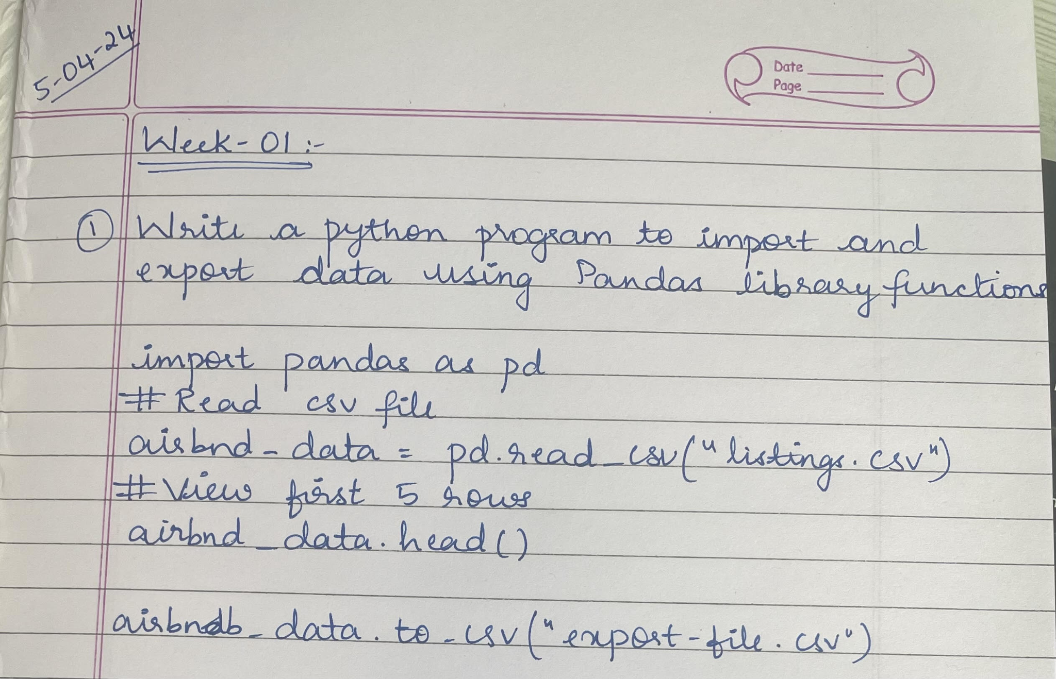

Code and output:

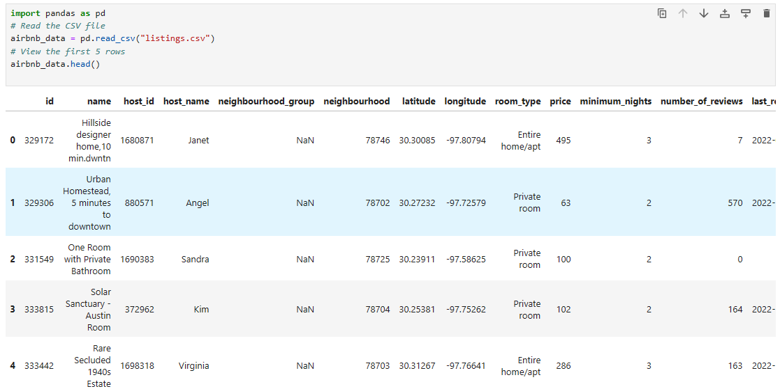



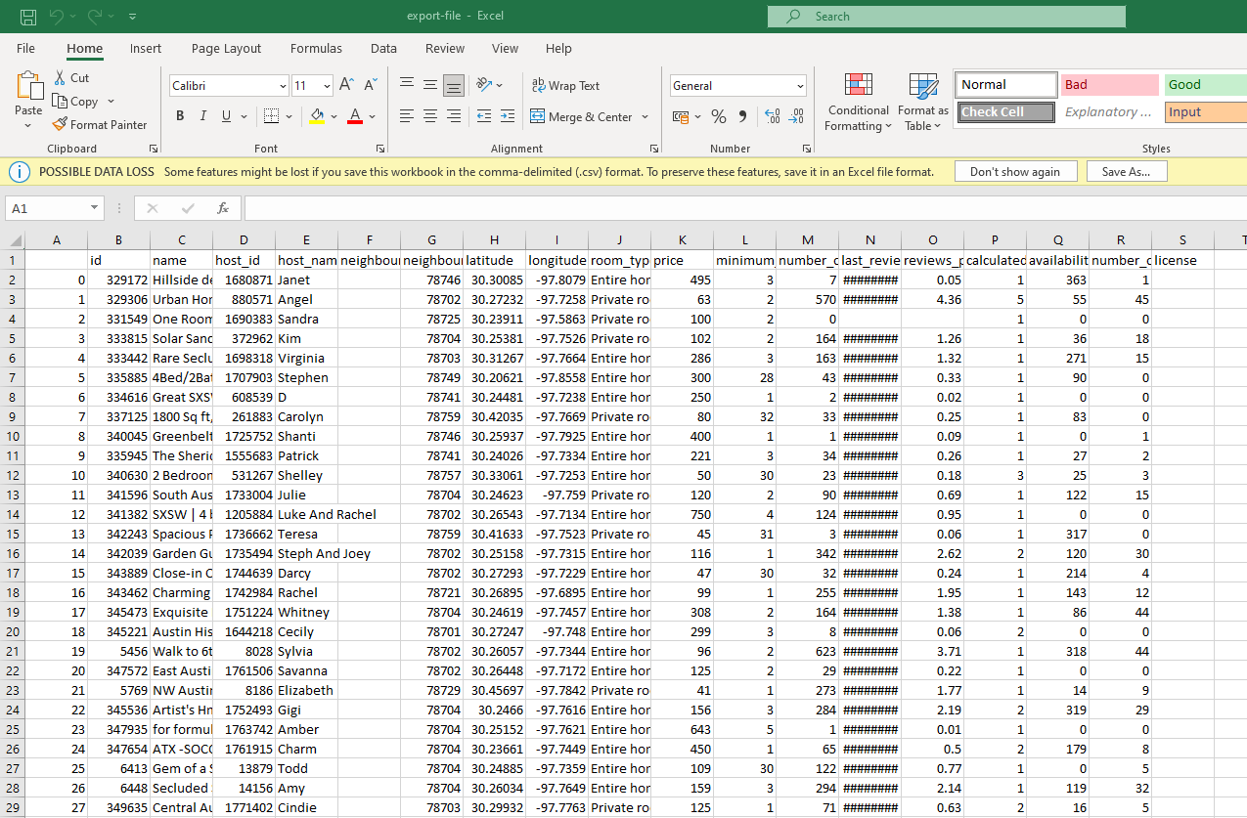

Reading data from URL:

Observation screenshot:

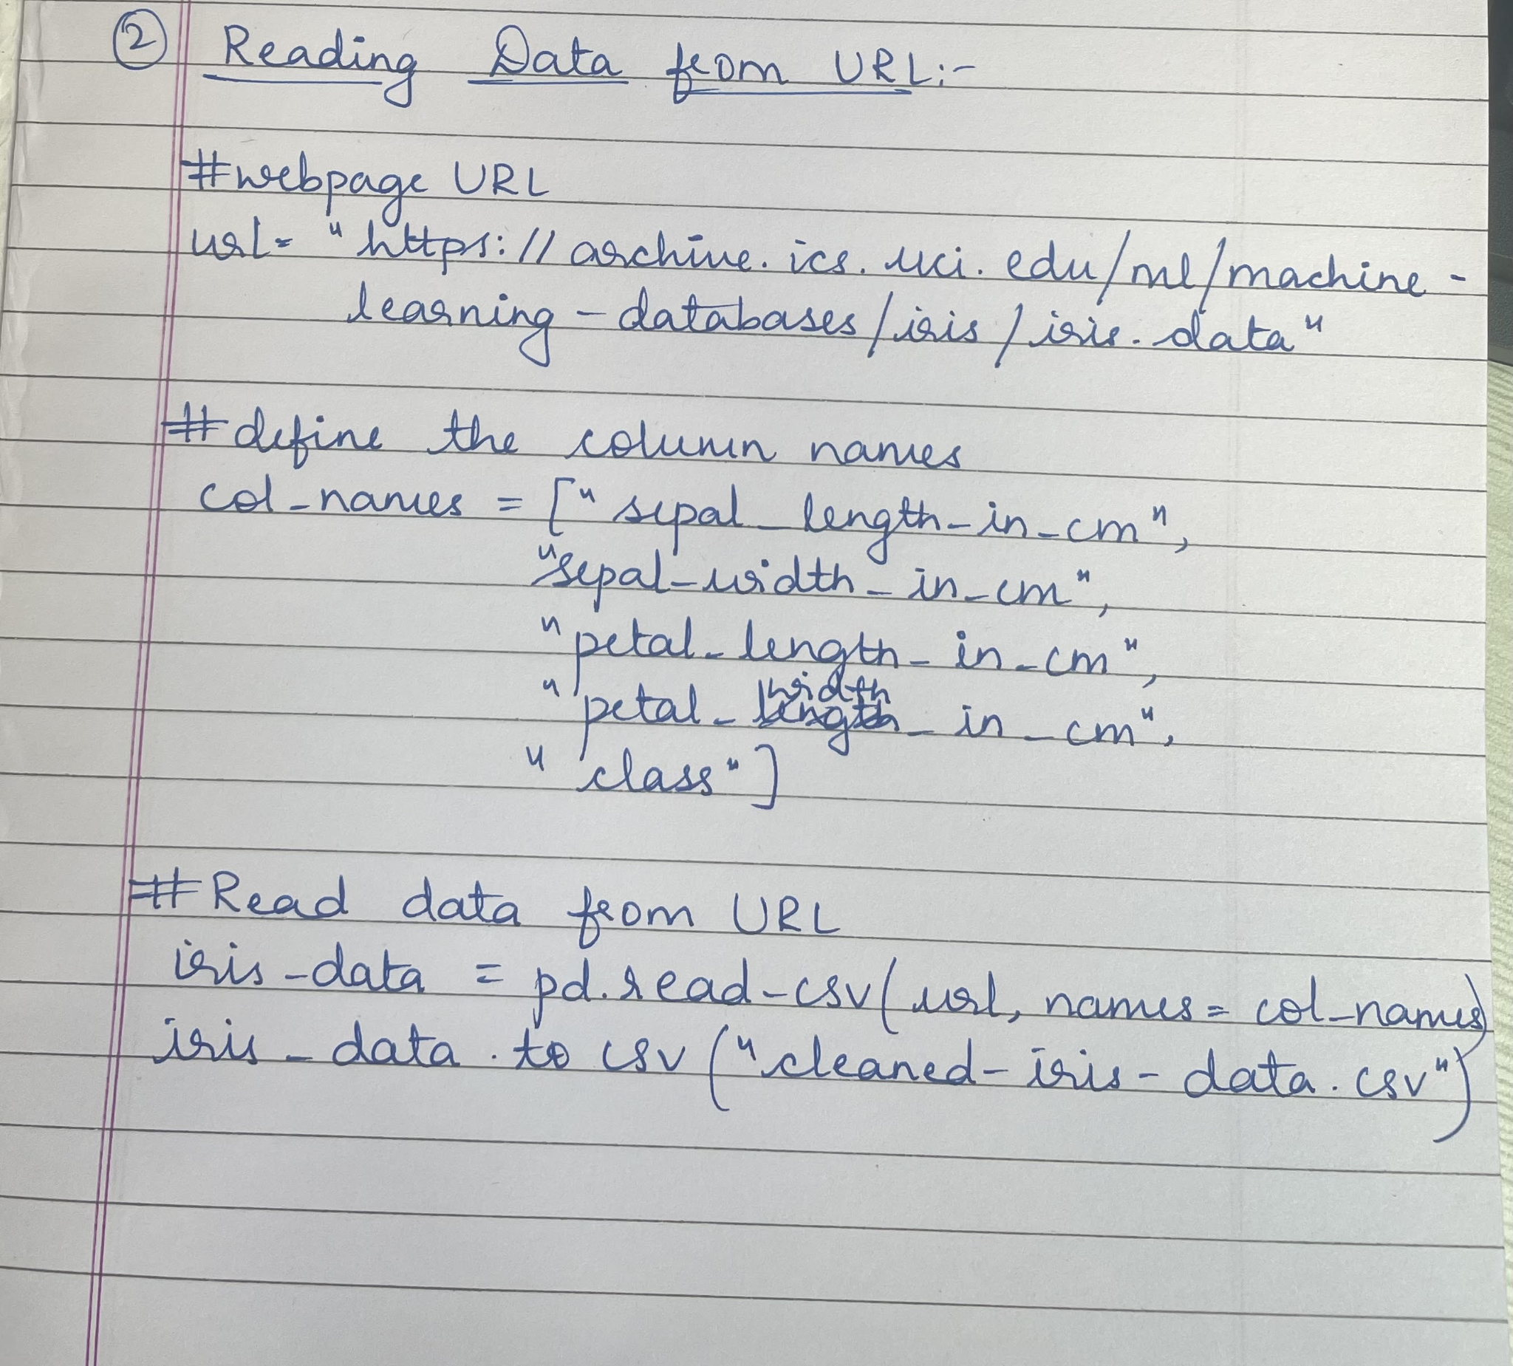

Code and output:

